Topic of the project:

Suggestion for the project name (Can you change): "ASIC design with open source tools"

Developing of an low resolution ADC. As example an 4-Bit ADC with conversion of the thermometer code into binary code.

Steps:  
**- make you familiar with xschem & ngspice (e.g. tutorial on youtube)**

<https://www.youtube.com/watch?v=bm3l21ExLOY&list=PLgsDG5BJZpBTEUaxjfvYUiMPpUPU_vQpr>

- create a small CMOS inverter with xschem and the sky130a technology (PDK) and simulate the circuit with ngspice

**Binary Logic level assumption**

<https://en.wikipedia.org/wiki/Logic_level>

|  |  |  |  |
| --- | --- | --- | --- |
| Technology | L Voltage | H Voltage | note |
| CMOS | 0 to 30% of Vdd | 70% of Vdd to Vdd | Vdd = Supply voltage |
|  | ≈0.5 Volt | ≈1.25 Volts | Vdd = 1.8 Volts |

Magic=>before importing netlist to ngspice check LVS net

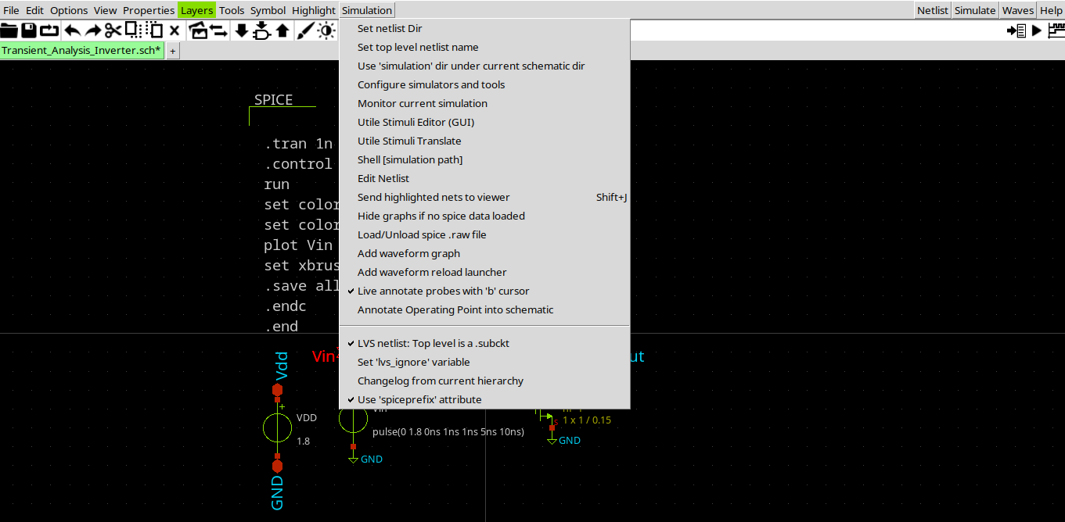

<http://web02.gonzaga.edu/faculty/talarico/vlsi/xschemTut.html>

<https://ngspice.sourceforge.io/ngspice-control-language-tutorial.html>

- write some verilog code to convert the thermometer code (from the inverter stages) into the binary code

<http://www.asic-world.com/verilog/veritut.html>

<https://www.youtube.com/playlist?list=PLfGJEQLQIDBN0VsXQ68_FEYyqcym8CTDN>

<https://github.com/Swagatika-Meher/msvsd2bitcomp>

<https://www.youtube.com/playlist?list=PLvXKBnlvcSm30Y0zu1765oG_x-ECU8tVG>

<https://learning.edx.org/course/course-v1:HarveyMuddX+ENGR85A+3T2021/home>

<https://www.vlsiuniverse.com/digital-thermometer-code-in-verilog-vhdl-flash-adc-binary-encoder/>

<https://www.classcentral.com/subject/vlsi?free=true>

<https://www.eng.biu.ac.il/temanad/digital-vlsi-design/>

<https://www.youtube.com/playlist?list=PLZU5hLL_713x0_AV_rVbay0pWmED7992G>

<https://youtu.be/BIqLk23hE90?list=PLZU5hLL_713x0_AV_rVbay0pWmED7992G>

- get familiar with the yosis syntesis tool to convert the verilog code into a CMOS circuit  
- simulate the complete (ultra small) ADC

References:

<https://github.com/bluecmd/learn-sky130/blob/main/schematic/xschem/getting-started.md>

* What is Schematic Capture and why do we need it?
* What is a process?

**Install xschem**

Method 1-----

<https://youtu.be/jXmmxO8WG8s>

<https://xschem.sourceforge.io/stefan/xschem_man/install_xschem.html>

<https://anthonywall.ie/opentools/>

*sudo apt install build-essential -y*

*sudo apt-get instsll flex -y*

*sudo apt-get install -y libx11-dev*

*sudo apt-get install -y tk8.6-dev*

*sudo apt-get install -y libxxpm-dev* flex bison

*git clone https://github.com/StefanSchippers/xschem.git xschem-src*

*cd xschem-src*

*./configure*

*make*

*sudo make install*

method 2-----

*sudo apt -y install xschem*

check the program location

*whereis xschem*

**install Magic**

*cd /home/..../Desktop*

*git clone git://opencircuitdesign.com/magic*

*cd magic*

*sudo apt-get install m4 tcsh csh libx11-dev tcl-dev tk-dev libcairo2-dev mesa-common-dev libglu1-mesa-dev libncurses-dev -y*

*./configure*

*make*

*sudo make install*

*make distclean*

**Install sky130**

Method 1-----

Method 2-----

<https://www.engineerwikis.com/wikis/installation-of-xschem>

cd …… Desktop

git clone https://github.com/google/skywater-pdk

cd skywater-pdk

git submodule init libraries/sky130_fd_io/latest

git submodule init libraries/sky130_fd_pr/latest

git submodule init libraries/sky130_fd_sc_hd/latest

git submodule init libraries/sky130_fd_sc_hdll/latest

# optional -----------

git submodule init libraries/sky130_fd_sc_hs/latest

git submodule init libraries/sky130_fd_sc_ms/latest

git submodule init libraries/sky130_fd_sc_ls/latest

git submodule init libraries/sky130_fd_sc_lp/latest

git submodule init libraries/sky130_fd_sc_hvl/latest

# --------------------

# You can skip the above optional command. But the following two commands must be run.

git submodule update

make timing

**Install open_pdks**

cd …./Desktop

git clone git://opencircuitdesign.com/open_pdks

cd open_pdks

./configure --enable-sky130-pdk=/home/……./Desktop/skywater-pdk

make

sudo make install

make distclean

**install Ngspice**

sudo apt-get install adms autoconf libtool libxaw7-dev libc6-dev gawk -y

sudo apt update

sudo apt upgrade

sudo apt-get install manpages-dev man-db manpages-posix-dev libreadline6-dev -y

sudo apt-get update -y

cd /home/...../Desktop

git clone <https://github.com/ngspice/ngspice.git>

cd ngspice

./autogen.sh –adms

mkdir release

cd release

./configure --with-x --with-readline=yes --disable-debug

make

sudo make install

**cd ~/.xschem**

**mkdir simulations**

**sudo nano .spiceinit-----[** **set ngbehavior=hs]**

**-----------------**

**Run iverilo/icarus**

iverilog file.v

vvp a.out

---------------------------

**Vdd = 5 Volt**

Vsat_max = 4.616

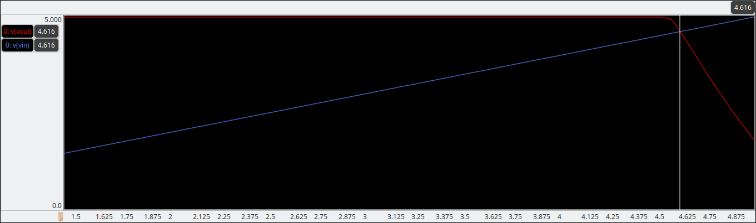

Vsat_min = 481.3mV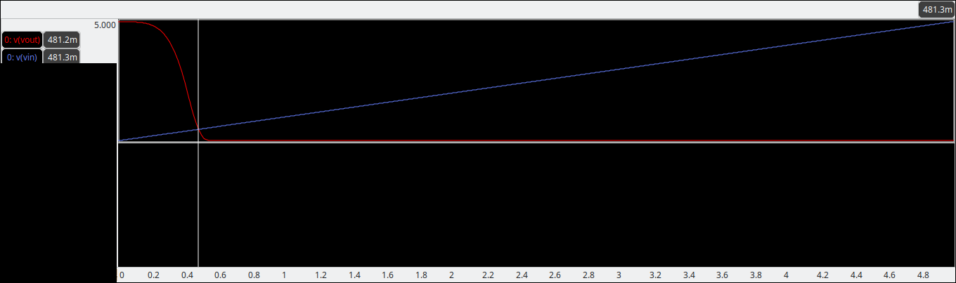

Voltage range = 4.616 – 0.4813 = 4.1347 V

Step voltage = 4.1347/15 = 0.275647

Set. 1: 0.4813

Set. 2: 0.756947

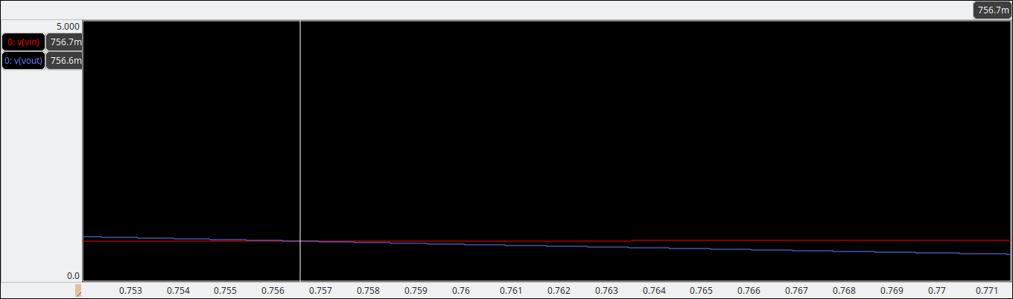

Set. 3: 1.032594

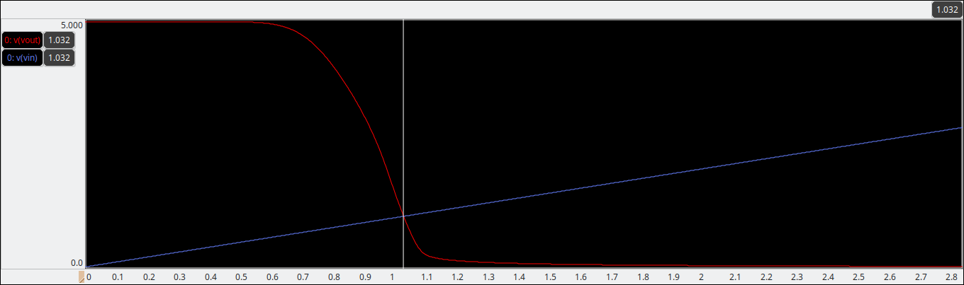

Set. 4: 1.308241

Set. 5: 1.583888

Set. 6: 1.859535

Set. 7: 2.135182

Set. 8: 2.410829

Set. 9: 2.686476

Set. 10: 2.96212

Set. 11: 3.23777

Set. 12: 3.513417

Set. 13: 3.789064

Set. 14: 4.064711

Set. 15: 4.340358

Set. 16: 4.616005

**Vdd = 1.8 V**

Sat. 1: 0.353900000

Sat. 2: 0.432773300

Sat. 3: 0.511646600

Sat. 6:0.748266500

Sat. 5:0.669393200

Sat. 4: 0.590519900

Sat. 7:0.827139800

Sat. 8:0.906013100

Sat. 9:0.984886400

Sat. 10:1.063759700

Sat. 11:1.142633000

Sat. 12:1.221506300

Sat. 13:1.300379600

Sat. 14:1.379252900